1. Selesai kan table kebenaran berikut.

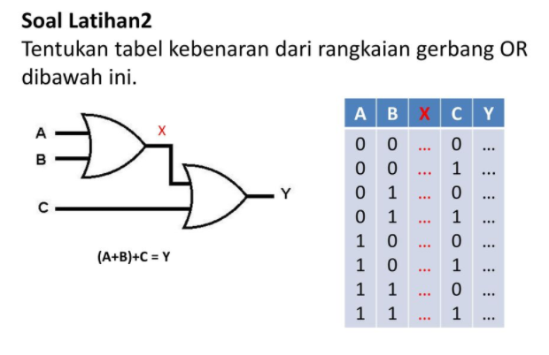

**KUMPULKAN DENGAN FORMAT .PDF**

**PERT3_NAMA_NPM_KELAS.pdf**

|  |  |  |  |
| --- | --- | --- | --- |
| A | B | C | Y |
| 0 | 0 | 0 | 0 |
| 0 | 0 | 1 | 1 |
| 0 | 1 | 0 | 1 |
| 0 | 1 | 1 | 1 |
| 1 | 0 | 0 | 1 |
| 1 | 0 | 1 | 1 |
| 1 | 1 | 0 | 1 |
| 1 | 1 | 1 | 1 |